**MINI-PROJECT: ATM- Working**

**KUNAL CHAVAN: 21SE02IT008**

**SATYAJEETSINH ATODARIYA: 21SE02IT002**

**B. Tech IT- SEM 2**

**Course Code: SEIT1030**

**Course Name: Object Oriented Programming with Java**

1. **Description of System:**

**FULLY FUNCTIONING GUI BASED ATM(Automated Teller Machine) PROJECT.**

1. **List of variables:**

**▪ Variable Name:**

* 1. **Bal**
  2. **Pin**
  3. **DAmount**
  4. **WAmount**

**▪ Data Types:**

* 1. **Integer**
  2. **String**
  3. **Integer**
  4. **Integer**

**▪ Purpose (Use):**

* 1. **To Store The Amount Of User Currency.**
  2. **To Store User Password.**
  3. **To Store The Amount User Want To Deposite From Account.**
  4. **To Store The Amount User Want To Withdrael From Account.**

# List of Methods:

**▪ Method Name (Complete Syntax):**

1. **main()**
2. **actionPerformed(ActionEvent e)**
3. **setBounds()**
4. **all set() & add() methods**

**▪ Purpose:**

1. **To start the execution of the code**
2. **To Perform a Block Of Code On Perticular Action(I.E- Button)**
3. **To Used In Such Situaton To Set The Position And Size.**

**4.To Use Methods Of Import Packages.**

# List of Overloaded and Overridden Methods:

# -NONE

# Class Inheritance Hierarchy (Super Class & Sub Class):

* **SuperClass- Jframe**
* **SubClass- Hello, ATM, Withdrawl, Deposite, Pin, Balance.**

# List of Constructors:

1. **Hello()**
2. **ATM()**
3. **Withdrawl()**
4. **Deposite()**
5. **Balance()**

# Code:

**Code Is Attached To WordFile(Due To Length Issue)**

# Functionality wise screen shoot of outputs:

1. **Login Checking Frame**

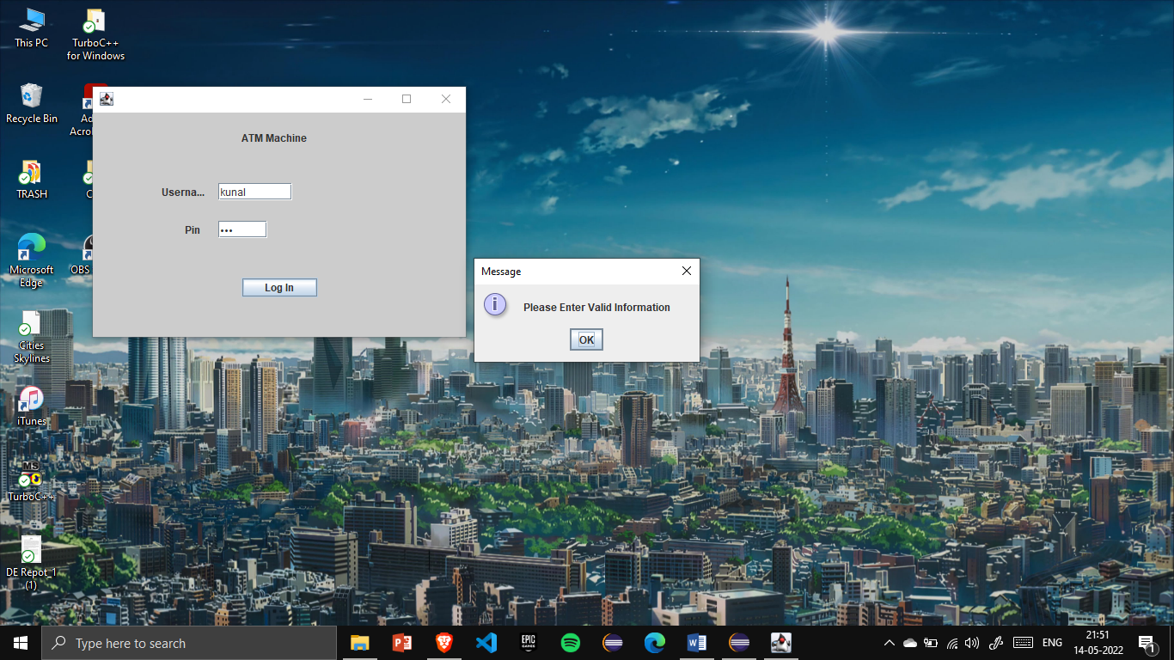

1. **Service Selection Window:**

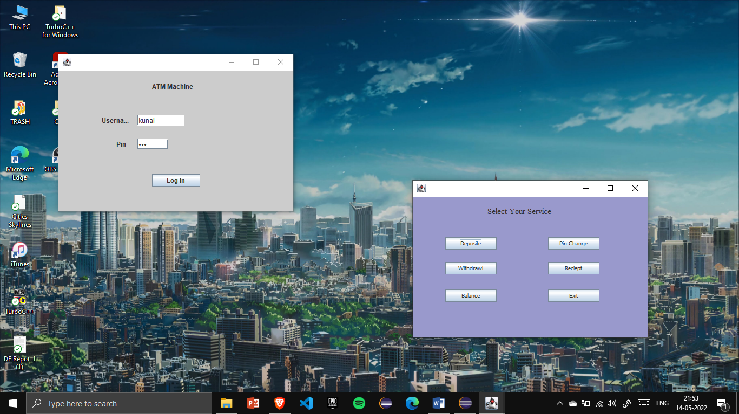

1. **Deposite Service Window:**

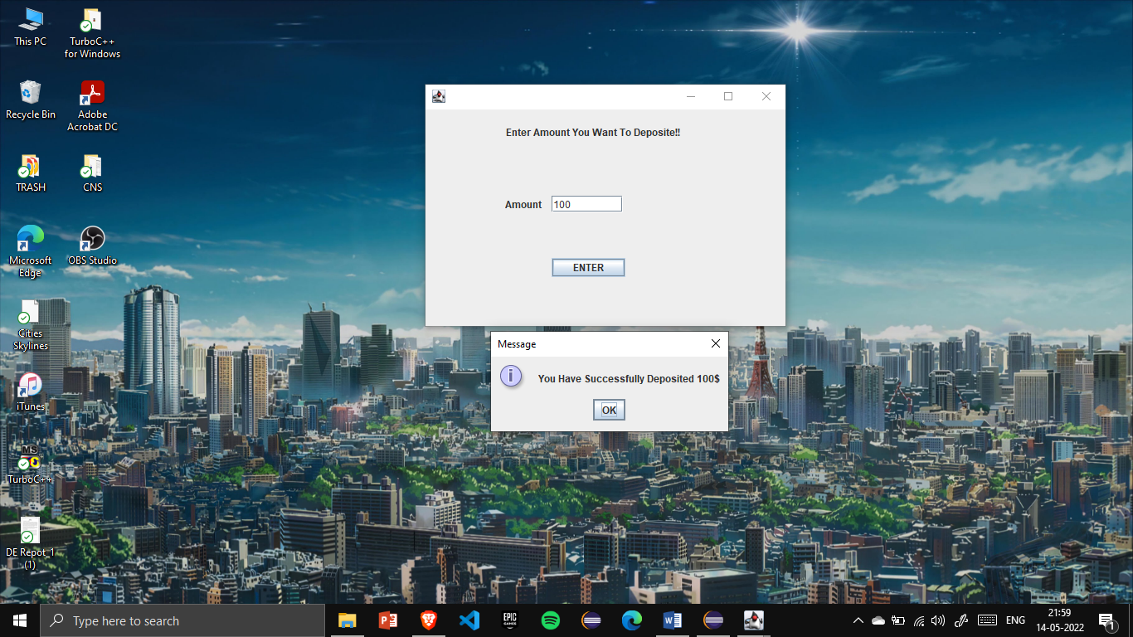

1. **Withdrawl Service Window:**

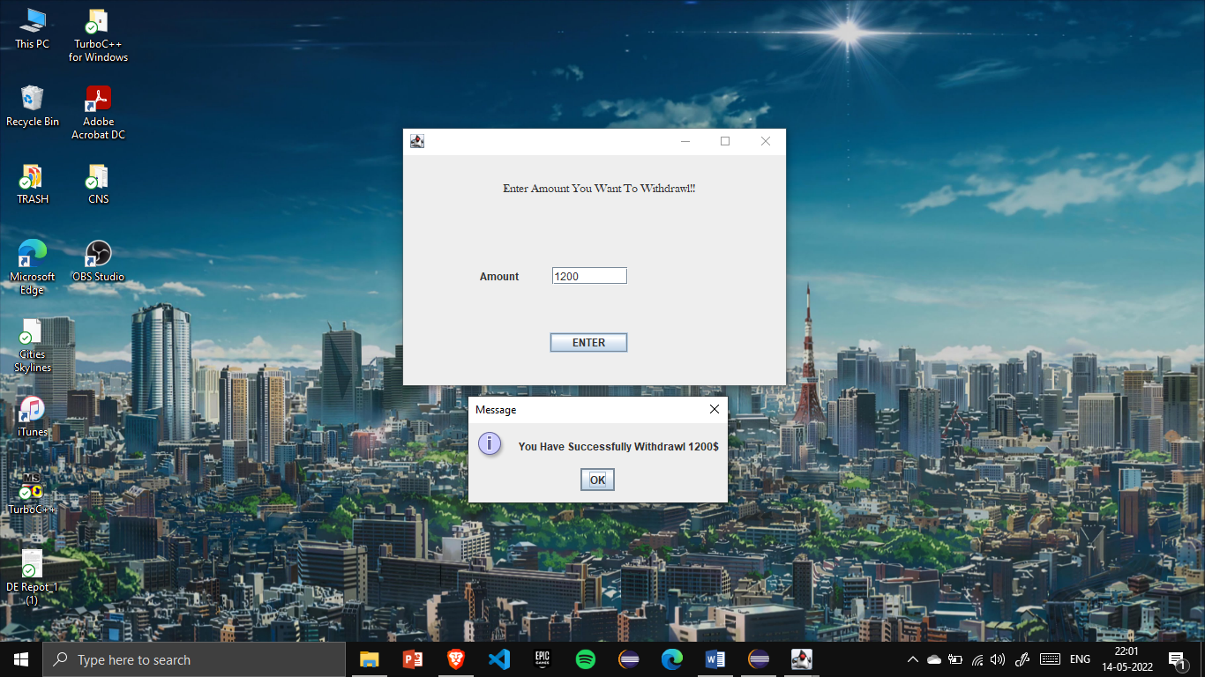

1. **Balance Service Window:**

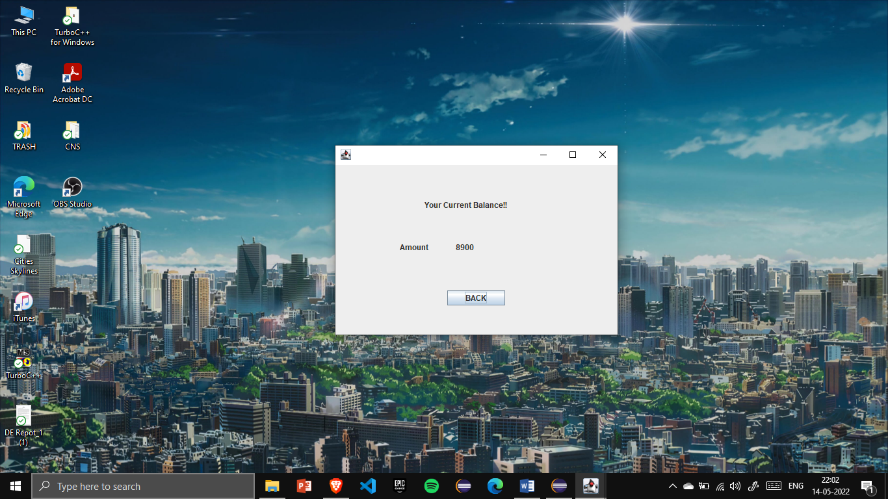

1. **Pin Service Window:**

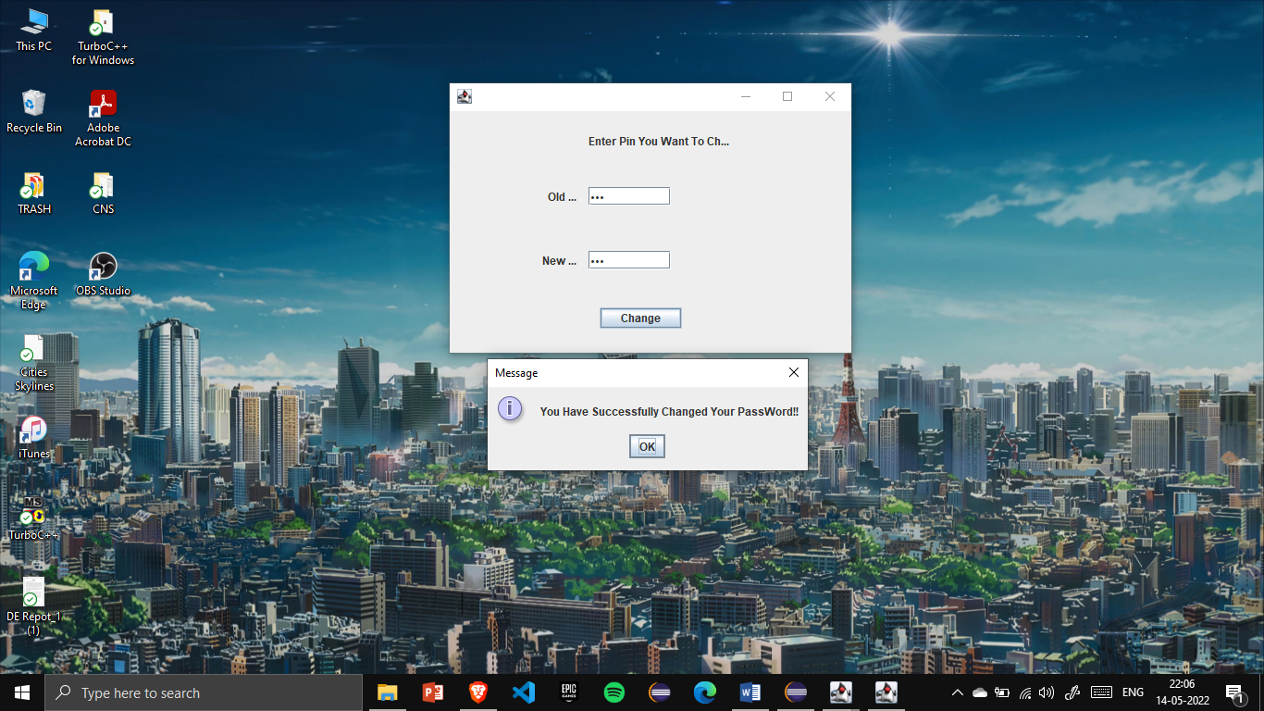

**THANK YOU**

